Experiment 1 – Flight Reservation System Using SaaS
Aim
To create a cloud-based Flight Reservation System using Zoho Creator as a Software as a Service (SaaS) application, allowing users to search, select, book, and manage flights through a web browser.
Procedure
- Open Zoho Creator and create a new application.
- Create the required forms such as Flights, Passengers, Bookings, Offers, Travel Preferences, SkyPoints, and Cancellation Records.
- Add flight details such as airline, flight number, source, destination, date, time, fare, class, and available seats.
- Create a user-friendly Flight Search page with options for:
  - One Way / Round Trip
  - From / To
  - Departure / Return Date
  - Travelers
  - Travel Class
- Create a Flight Results page to display available flights with fare, duration, airline, and seat availability.
- Add options to view, compare, and select a flight.
- Create Passenger Details and Travel Preferences forms.
- Implement automatic fare calculation using flight fare, travelers, meal, baggage, insurance, and discount.
- Create offers such as SKY10, STUDENT5, and FLY500.
- Use Deluge workflows to generate a unique Booking ID and store the booking.
- Automatically decrease available seats after successful booking.
- Create My Bookings and Manage Booking pages for viewing, modifying, and cancelling bookings.
- On cancellation, restore the available seats and create a cancellation record.
- Create an Admin Dashboard showing actual flight, booking, revenue, and cancellation information.
- Test the complete process from flight search → booking → confirmation → management/cancellation.
OUTPUT:
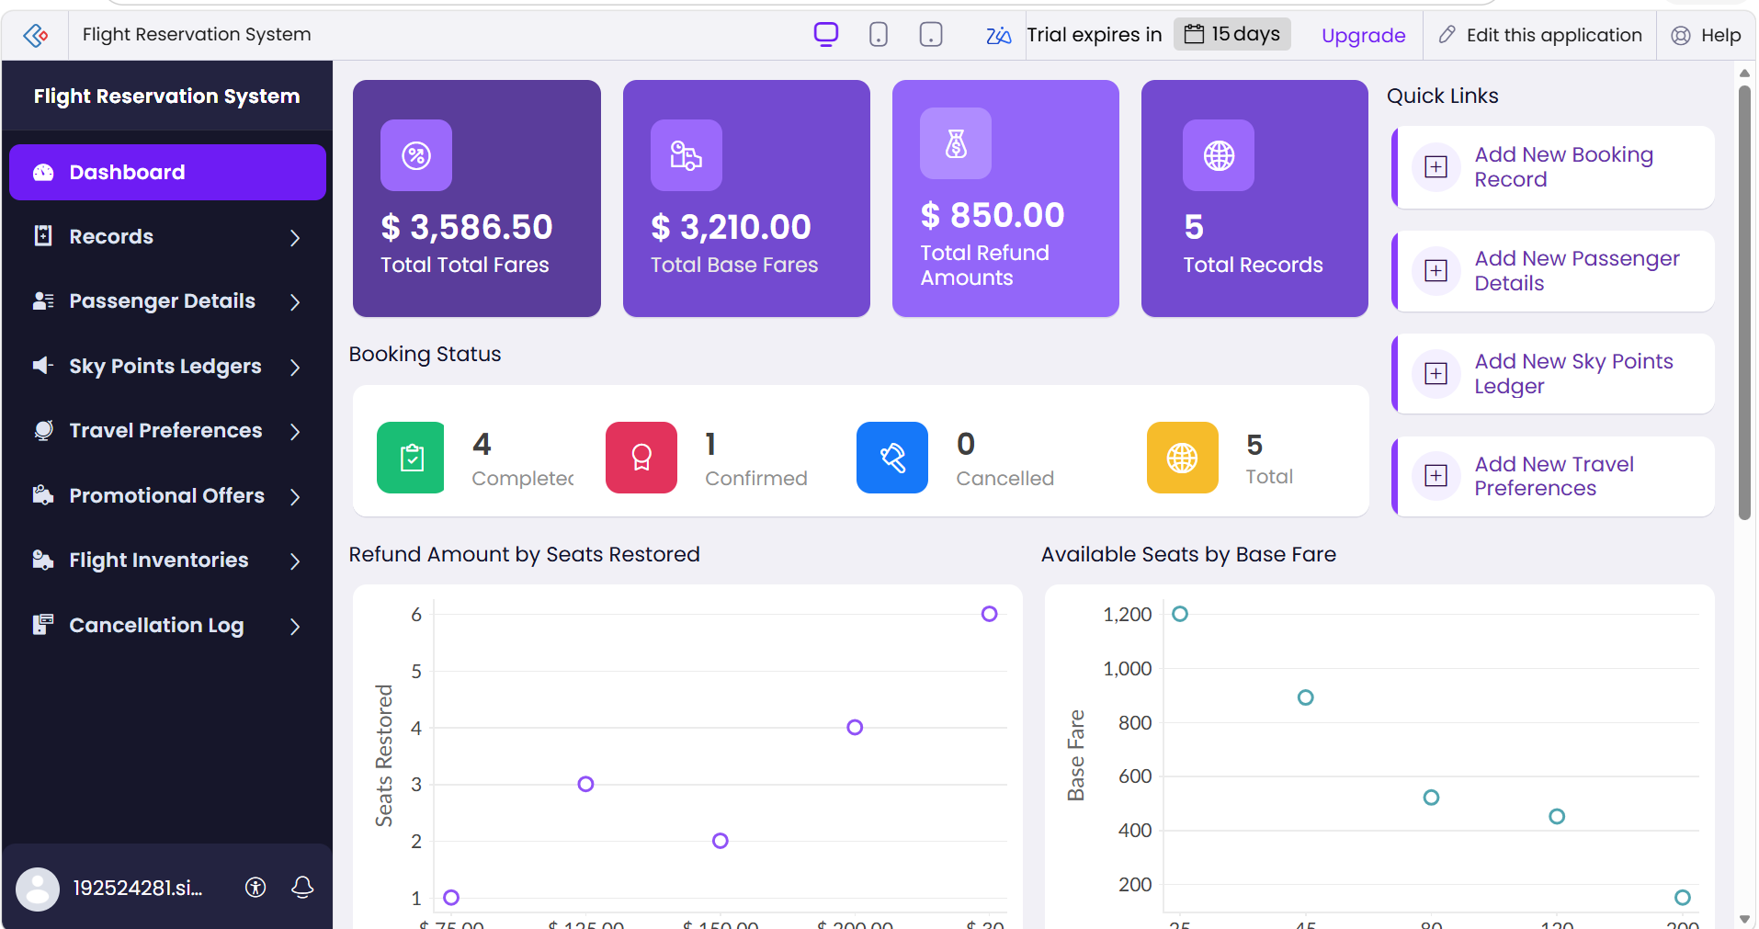
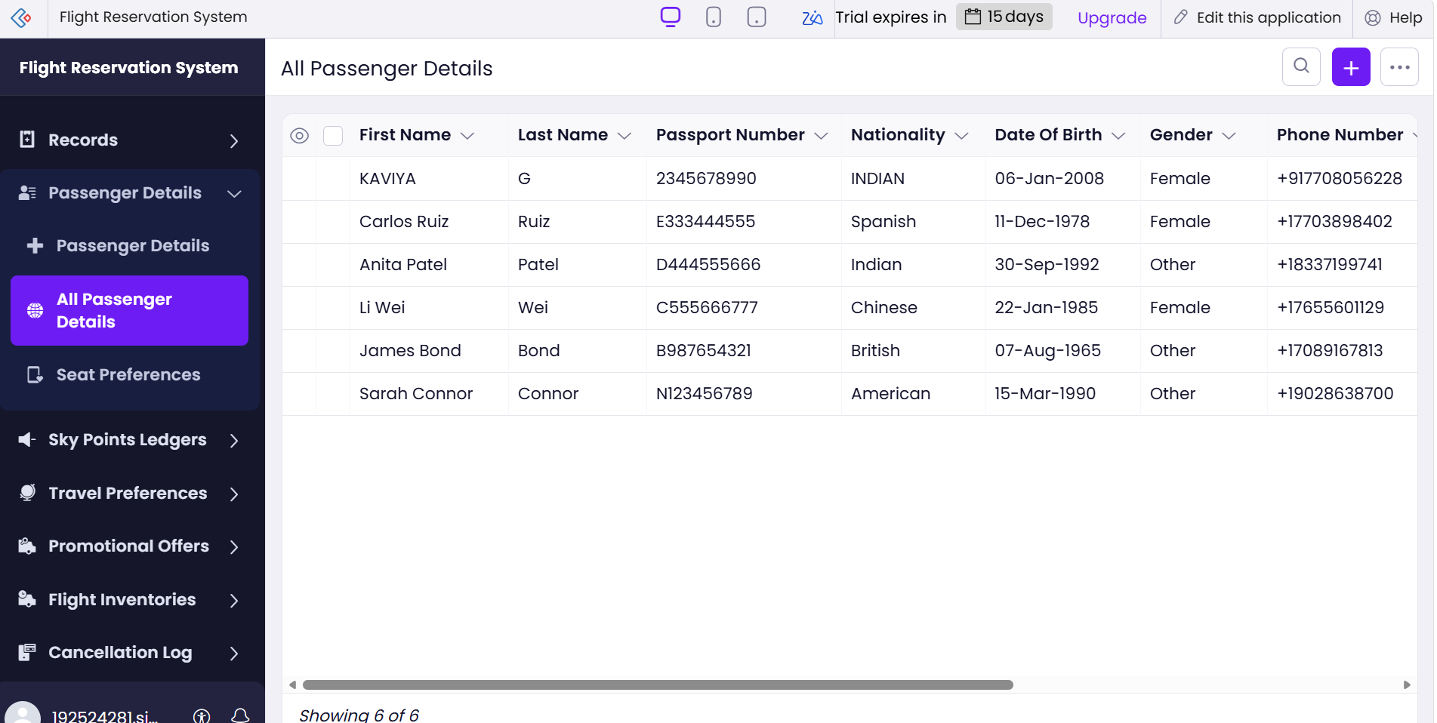
Result
Thus, a fully functional cloud-based Flight Reservation System was created using Zoho Creator, demonstrating the Software as a Service (SaaS) model with cloud forms, database, reports, and automated workflows.

2. PROPERTY MANAGEMENT SYSTEM
AIM
To develop a simple cloud-based Property Buying and Rental Management System for Chennai city using a Cloud Service Provider, thereby demonstrating the Software as a Service (SaaS) model.
PROCEDURE
- Open Zoho Creator and sign in using a Zoho account.
- Create a new application named “Chennai Property Buying & Rental System.”
- Create a form named “Property Details.”
- Add the following fields:
  - Property ID
  - Owner Name
  - Customer Name
  - Transaction Type – Buy / Rent
  - Property Type – Residential / Commercial
  - Area
  - Place
  - Property Address
  - Range
  - Property Value
  - Monthly Rent
  - Rental Agreement – Yes / No
  - Contact Number
- Add sample Chennai locations such as Anna Nagar, T. Nagar, Velachery, Tambaram, Adyar, and OMR.
- Create a Property Details Report to display the entered property information.
- Create a Property Search page to search properties based on:
  - Buy / Rent
  - Area
  - Place
  - Property Type
  - Price Range
- Create a simple dashboard to display available properties and their details.
- Test the application by entering sample property records.
- Deploy the application through Zoho Creator so that it can be accessed through the cloud.
OUTPUT:
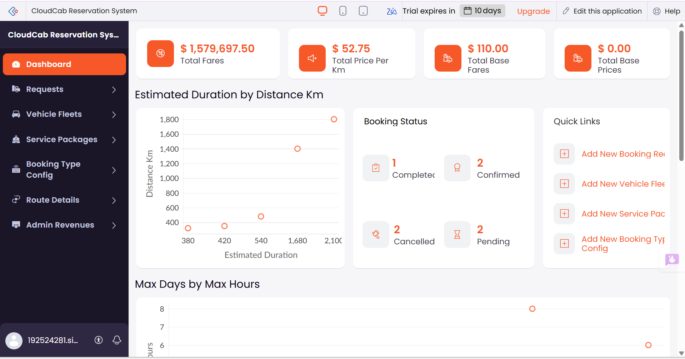
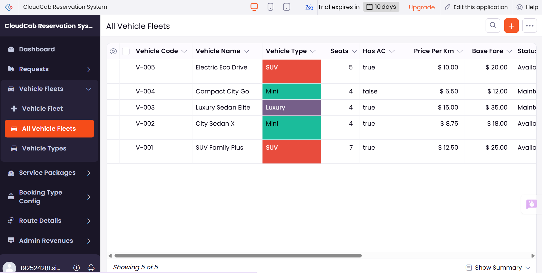

RESULT
Thus, a cloud-based Property Buying and Rental Management System for Chennai city was successfully created using Zoho Creator. The application demonstrates the SaaS model by managing property buying, rental, commercial properties, rental agreements, locations, price ranges, and property values.

3. CLOUD-BASED CAR BOOKING RESERVATION SYSTEM (SaaS)
AIM
To develop a simple cloud-based Car Booking Reservation System using a Cloud Service Provider to demonstrate the Software as a Service (SaaS) model, including cab search, pickup and destination locations, rental/outstation booking, package type, and duration.
PROCEDURE
1. Select a Cloud Service Provider
- Use a cloud platform such as Google Firebase, AWS, or Microsoft Azure.
- Create an account and configure a simple web application.
2. Design the Booking Interface
Create a booking form with the following fields:
- Search for Cabs
- From – Pickup Location
- To – Destination
- Booking Type – Rental / Outstation
- Package Type – Local / Outstation / Airport
- Duration – Hours / Days
- Date and Time
- Car Type – Sedan / SUV / Hatchback
- Number of Passengers
- Name and Contact Number
3. Implement the Application
- Design the user interface using HTML, CSS, and JavaScript.
- Add input fields, dropdown menus, and a Search Cabs button.
- Display available cars according to the selected requirements.
4. Connect to the Cloud
- Connect the application to a cloud database such as Firebase Firestore.
- Store booking details in the cloud.
- Deploy the application using the cloud provider's hosting service.
5. Test the Application
- Enter pickup and destination locations.
- Select Rental or Outstation.
- Select the package type and duration.
- Search for available cabs.
- Select a suitable cab and submit the booking.
6. Demonstrate SaaS Functionality
- Access the application through a web browser.
- Use the software without installing it locally.
- Store and manage booking information through the cloud.
OUTPUT:
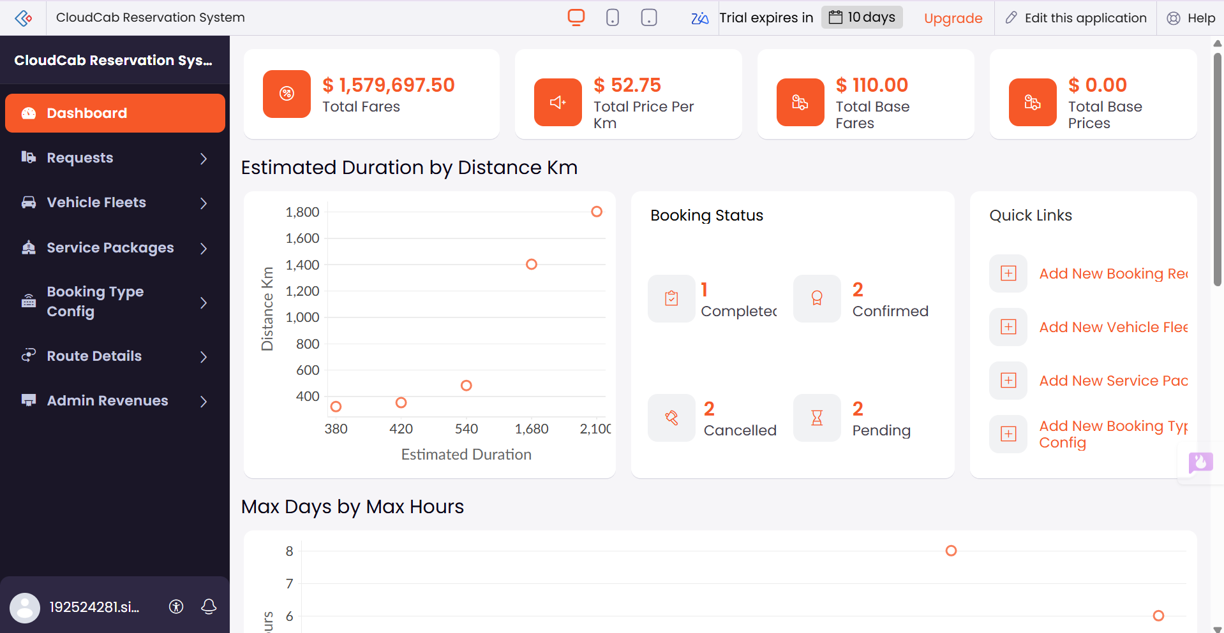
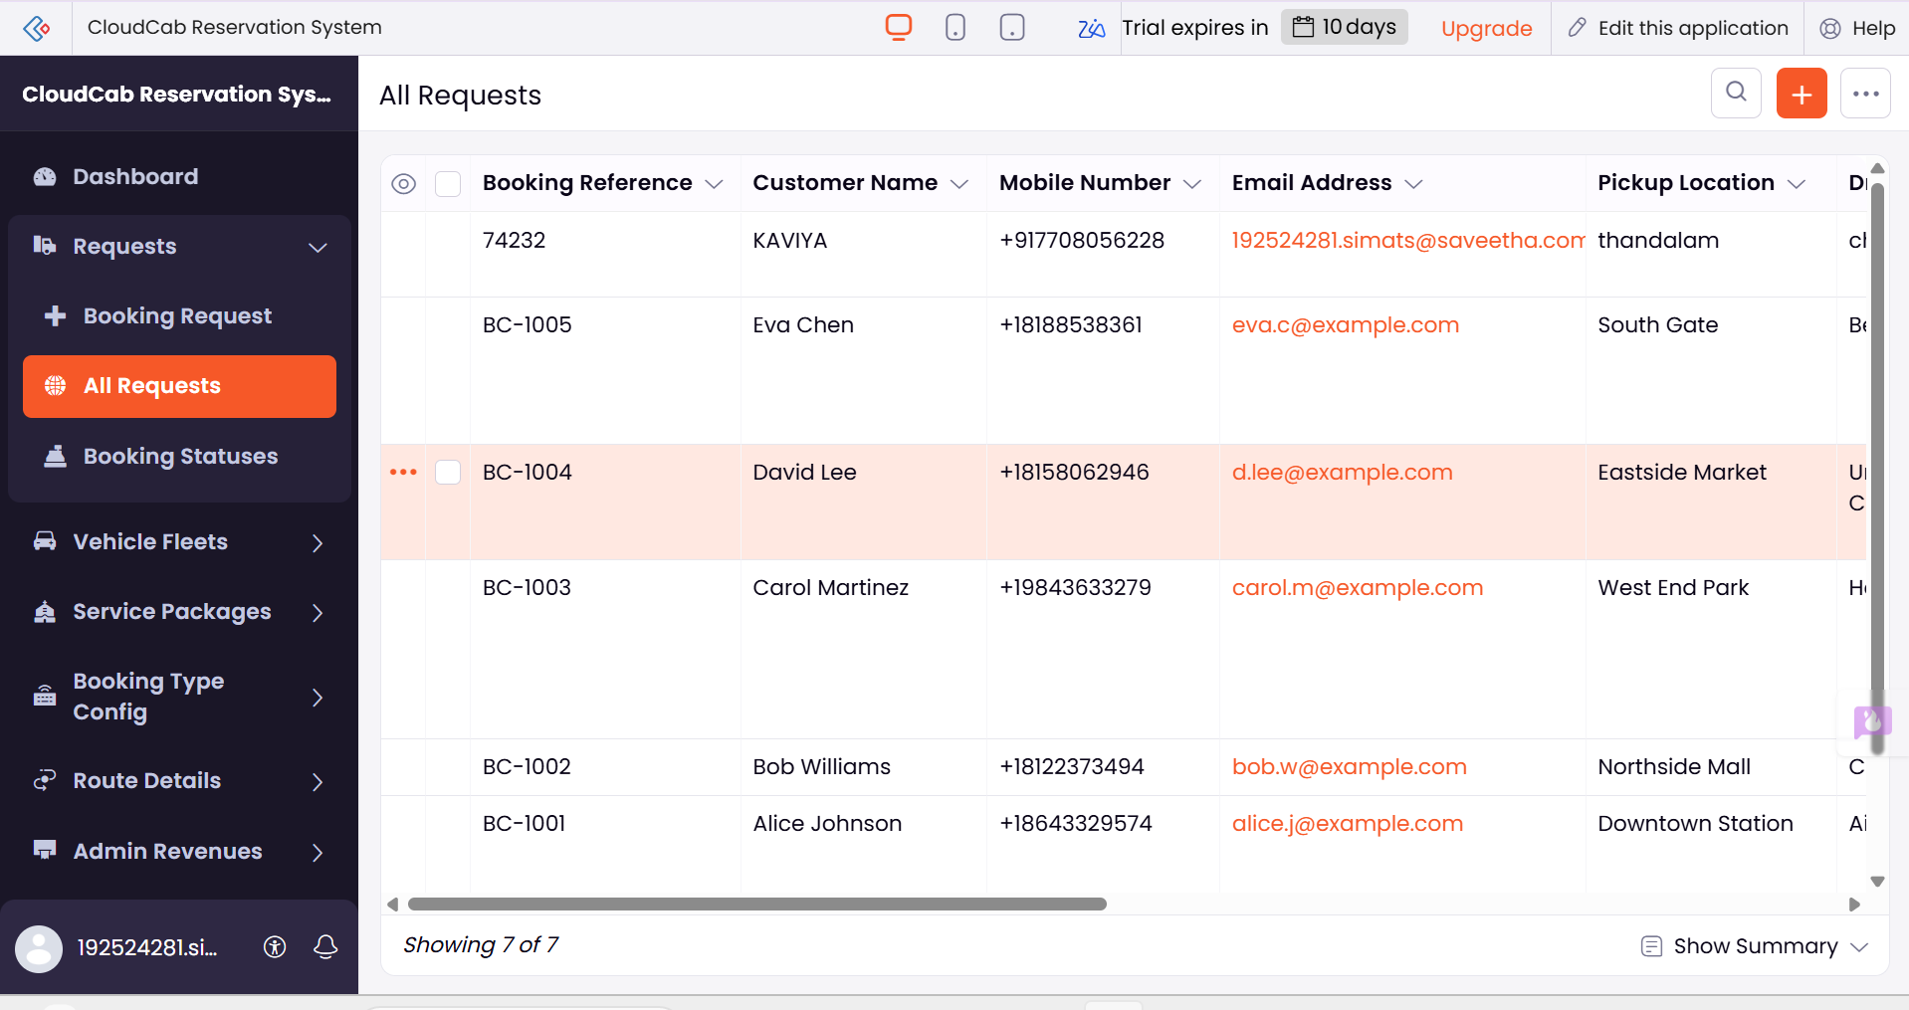
RESULT
Thus, a cloud-based Car Booking Reservation System was successfully created and deployed using a Cloud Service Provider. The system provides cab search, From/To locations, Rental/Outstation options, Package Type, Hours/Days, car selection, and booking details, thereby demonstrating the SaaS model.

4. CLOUD-BASED LIBRARY BOOK RESERVATION SYSTEM
AIM
To develop a simple cloud-based Library Book Reservation System for SIMATS Library using a Cloud Service Provider to demonstrate the Software as a Service (SaaS) model, including book and reservation details.
PROCEDURE
1. Select a Cloud Service Provider
- Use a cloud platform such as Google Firebase, AWS, or Microsoft Azure.
- Create an account and configure a cloud-based application.
2. Design the Library Interface
Create a form containing the following fields:
- Title of the Book
- Author
- Publication
- Year of Publication
- Edition
- Number of Copies
- Rack Number
- Status – Taken / Returned
- Student Name
- Student ID
- Reservation Date
3. Develop the Application
- Create the interface using HTML, CSS, and JavaScript.
- Add input fields, dropdown menus, and buttons such as:
  - Search Book
  - Reserve Book
  - Submit
- Display available books and their current status.
4. Connect to the Cloud Database
- Connect the application to Firebase Firestore or another cloud database.
- Store book and reservation details securely in the cloud.
- Update the book status when a book is reserved or returned.
5. Test the Application
- Enter book details such as title, author, publication, year, edition, and rack number.
- Search for a required book.
- Check the number of available copies.
- Reserve an available book.
- Change the status from Returned to Taken when reserved and update it back when returned.
6. Demonstrate SaaS
- Deploy the application on the cloud.
- Access the system through a web browser from different devices.
- Use the library reservation software without local installation.
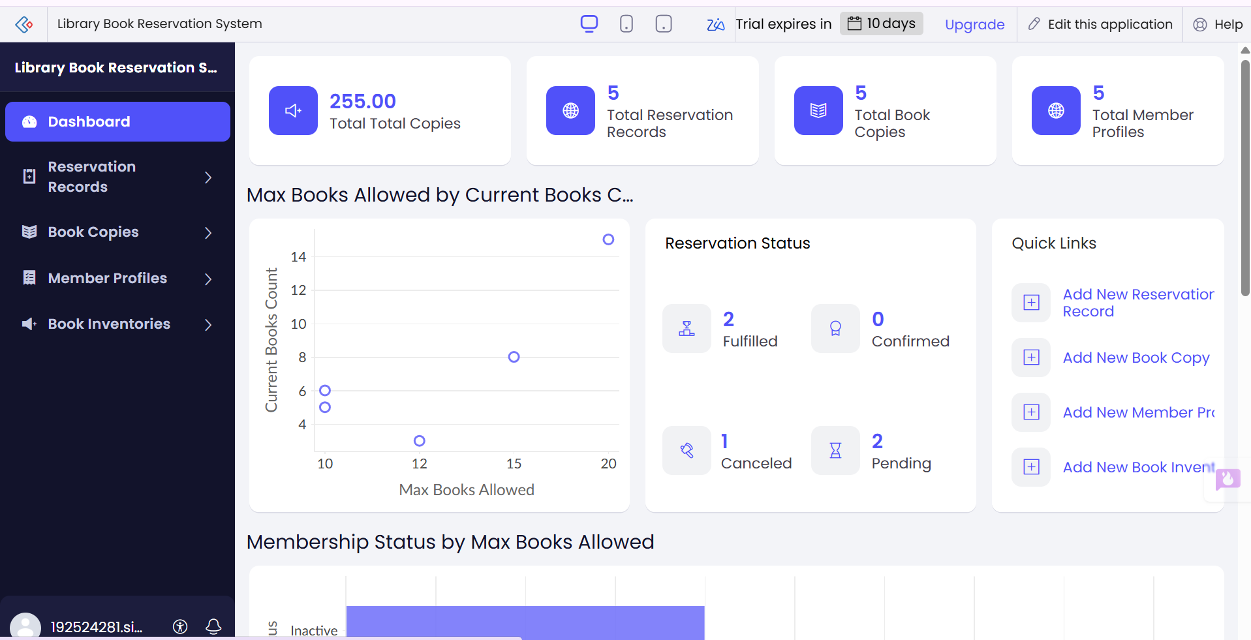
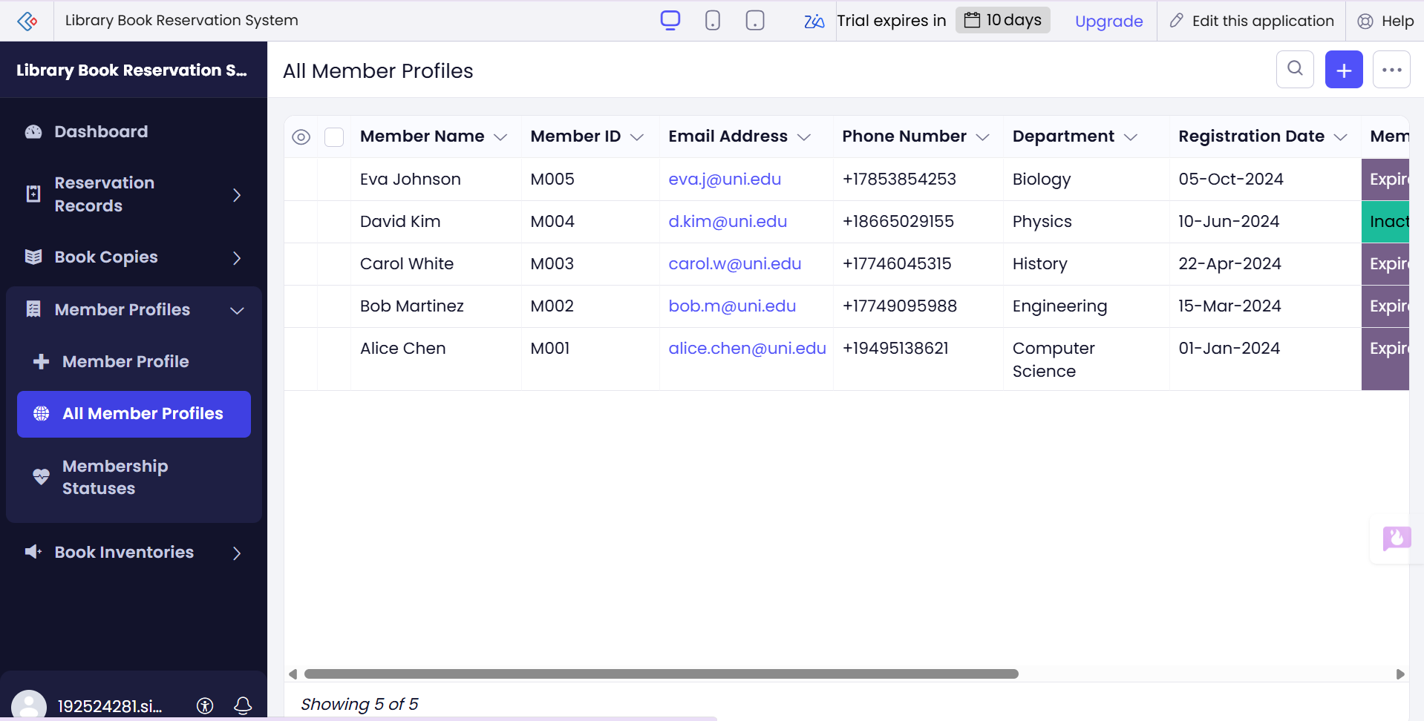
RESULT
Thus, a cloud-based Library Book Reservation System for SIMATS Library was successfully created using a Cloud Service Provider. The system manages book title, author, publication, year, edition, number of copies, rack number, and taken/returned status, and allows users to search and reserve books through a cloud-based SaaS application.

5. CLOUD-BASED MARK SHEET PROCESSING SYSTEM
AIM
To develop a simple cloud-based Mark Sheet Processing System using a Cloud Service Provider to demonstrate the Software as a Service (SaaS) model, including student details, subject-wise marks, total, average, percentage, rank, and overall performance.
PROCEDURE
1. Select a Cloud Service Provider
- Use a cloud platform such as Google Firebase, AWS, or Microsoft Azure.
- Create an account and configure a simple cloud application.
2. Design the Mark Sheet Form
Create a form containing:
- Name of the Student
- Register Number
- Subject 1 and Marks
- Subject 2 and Marks
- Subject 3 and Marks
- Subject 4 and Marks
- Subject 5 and Marks
- Total Marks
- Average
- Percentage
- Rank
- Overall Performance
3. Develop the Application
- Create the user interface using HTML, CSS, and JavaScript.
- Provide input fields for student information and marks.
- Add a Calculate Result button.
- Automatically calculate total marks, average, and percentage.
4. Calculate the Results
Total Marks = Sum of all Subject Marks
Average = Total Marks ÷ Number of Subjects
Percentage = (Total Marks ÷ Maximum Marks) × 100
- Rank can be assigned by comparing students' percentages.
- Overall performance can be classified as Excellent, Very Good, Good, or Average based on percentage.
5. Connect to the Cloud
- Connect the application to a cloud database such as Firebase Firestore.
- Store student details and calculated marks securely.
- Retrieve and display mark sheets whenever required.
6. Test the Application
- Enter the student's name and register number.
- Enter marks for all subjects.
- Click Calculate Result.
- Verify total, average, percentage, rank, and overall performance.
- Save the result in the cloud database.
7. Demonstrate SaaS
- Deploy the application using the selected Cloud Service Provider.
- Access the application through a web browser.
- Process and view mark sheets without installing software locally.
OUTPUT:
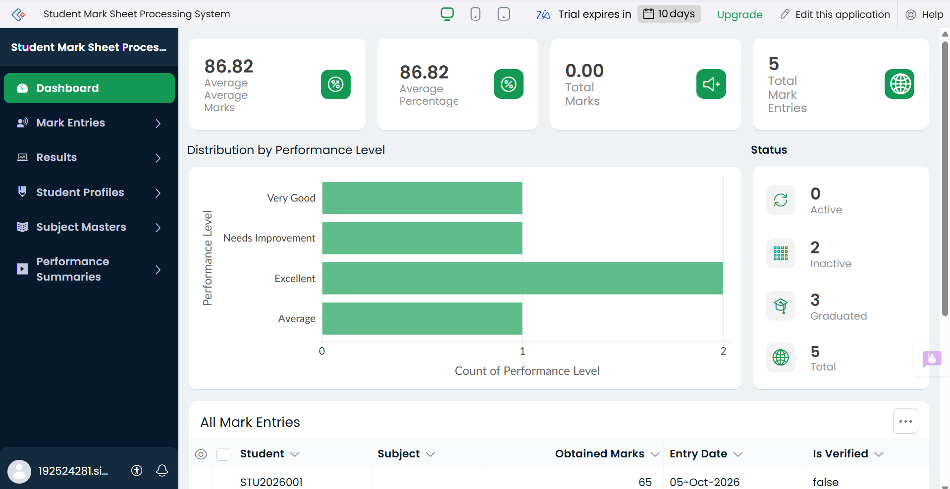
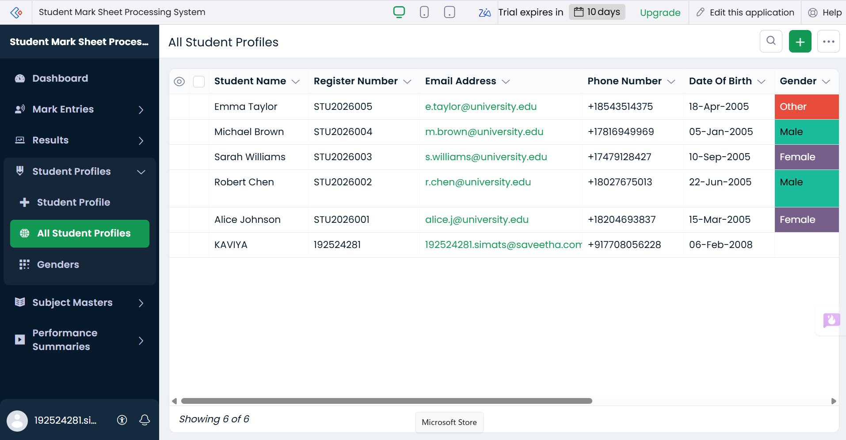
RESULT
Thus, a cloud-based Mark Sheet Processing System was successfully created using a Cloud Service Provider. The system processes student name, register number, subject-wise marks, total, average, percentage, rank, and overall performance, demonstrating the Software as a Service (SaaS) model.

6. PAYROLL PROCESSING SYSTEM USING CLOUD SaaS
AIM
To develop a simple cloud-based Payroll Processing System using a Cloud Service Provider to demonstrate the Software as a Service (SaaS) model, including employee details and salary components such as Basic Pay, HRA, DA, TA, Gross Pay, and Net Pay.
PROCEDURE
1. Select a Cloud Service Provider
Use Google Cloud Platform (GCP), AWS, or Microsoft Azure to host the application.
2. Create the Payroll Application
Develop a simple web-based payroll application with an employee salary form.
3. Add the Required Fields
- Employee Name
- Employee ID
- Department
- Designation
- Experience in Present Organization
- Overall Experience
- Basic Pay
- HRA
- DA
- TA
- Gross Pay
- Deductions
- Net Pay
4. Enter Employee Details
Enter the employee's personal, professional, and salary information through the application.
5. Calculate Salary
Gross Pay = Basic Pay + HRA + DA + TA
Net Pay = Gross Pay − Deductions
6. Store the Data in the Cloud
Store employee and payroll information in a cloud database so that it can be accessed through the web application.
7. Deploy the Application
Deploy the application on the selected cloud platform and access it through a web browser.
8. Test the Application
Verify that employee details are stored correctly and that Gross Pay and Net Pay are calculated accurately.
SAMPLE OUTPUT
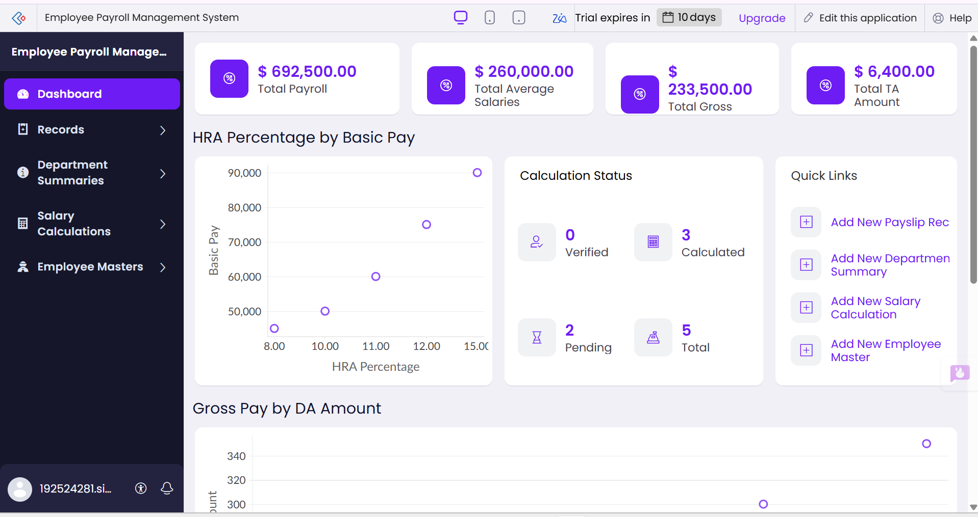
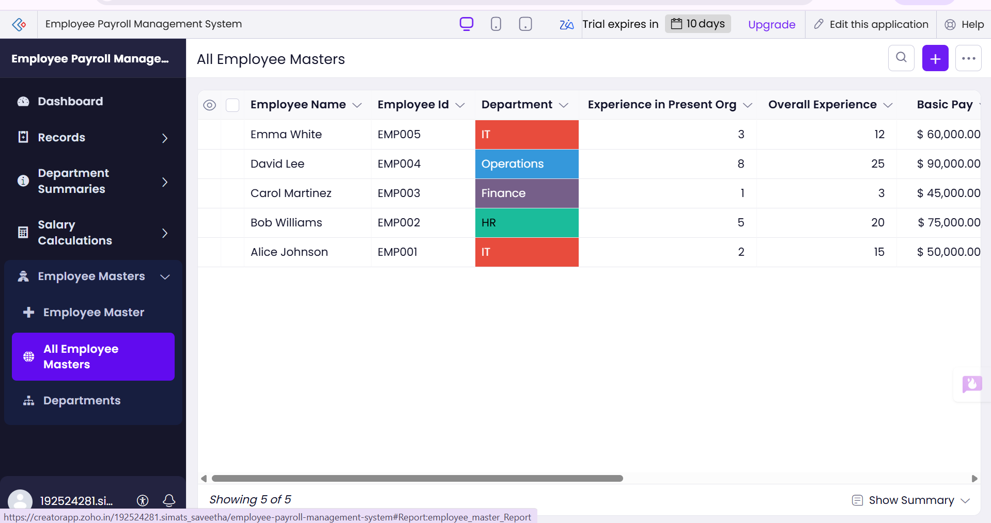
Field | Example
Employee Name | Arun Kumar
Employee ID | EMP101
Experience in Present Organization | 3 Years
Overall Experience | 5 Years
Basic Pay | ₹30,000
HRA | ₹6,000
DA | ₹3,000
TA | ₹2,000
Gross Pay | ₹41,000
Deductions | ₹3,000
Net Pay | ₹38,000
RESULT
Thus, a cloud-based Payroll Processing System was successfully created and deployed using a Cloud Service Provider. The system stores employee details and automatically calculates Gross Pay and Net Pay, demonstrating the concept of Software as a Service (SaaS).

7. STUDENTS ATTENDANCE SYSTEM USING CLOUD SaaS
AIM
To develop a simple cloud-based Students Attendance System using a Cloud Service Provider to demonstrate the Software as a Service (SaaS) model, including student details, course attendance, OD requests, grades, and attendance percentage.
PROCEDURE
1. Select a Cloud Service Provider
Use a cloud platform such as Google Cloud Platform (GCP), AWS, or Microsoft Azure.
2. Create the Attendance Application
Develop a simple web-based application for recording and managing student attendance.
3. Add the Required Fields
- Student Name
- Register Number
- Course
- Department
- Total Classes
- Present
- Absent
- Course Attendance
- OD Request
- Attendance Percentage
- Grade
- Remarks
4. Enter Student Details
Enter the student's name, register number, course, department, and other required information.
5. Record Attendance
Mark each student's attendance as Present or Absent for every class.
6. Handle OD Requests
Record and manage On-Duty (OD) requests submitted by students.
7. Calculate Attendance Percentage
Attendance Percentage = (Present Classes ÷ Total Classes) × 100
OD-approved classes can be handled according to the institution's attendance rules.
8. Assign Grade
Assign an appropriate attendance grade or status based on the attendance percentage.
9. Store Data in the Cloud
Store attendance records in a cloud database so that authorized users can access them through the internet.
10. Deploy and Test the Application
Deploy the application on the selected cloud platform and verify that attendance records and percentages are calculated correctly.
SAMPLE OUTPUT
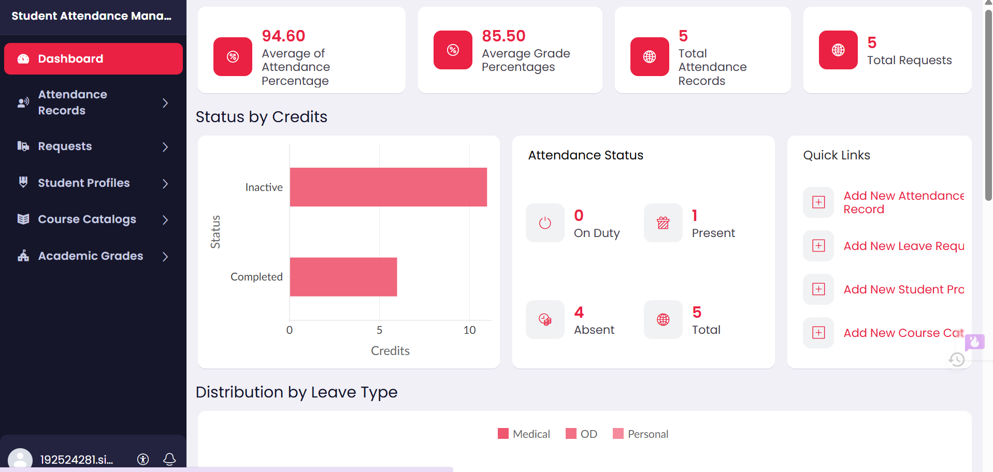
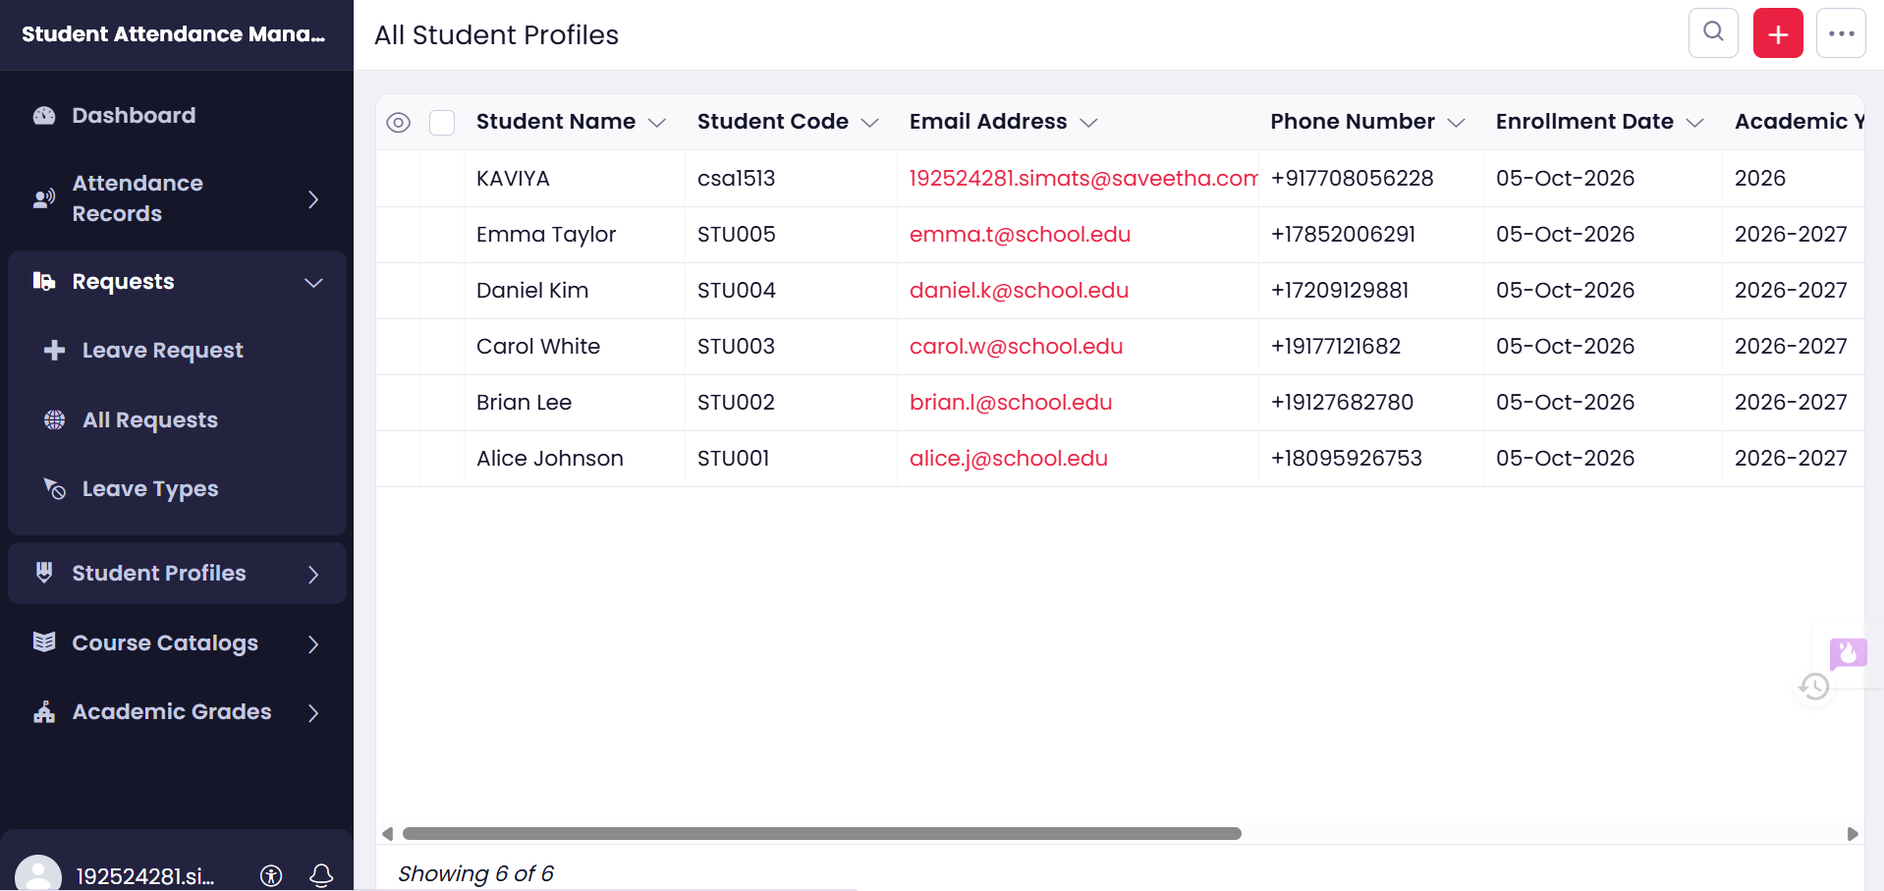
Field | Example
Student Name | Anitha
Register Number | 23CS101
Course | Cloud Computing
Total Classes | 40
Present | 36
Absent | 4
Course Attendance | 90%
OD Request | Approved
Attendance Percentage | 90%
Grade | A
Remarks | Good Attendance
RESULT
Thus, a cloud-based Students Attendance System was successfully created and deployed using a Cloud Service Provider. The system manages student attendance, OD requests, attendance percentage, and grades, thereby demonstrating the concept of Software as a Service (SaaS).

8. STUDENT COUNSELLING SYSTEM USING CLOUD SaaS
AIM
To develop a simple cloud-based Student Counselling System using a Cloud Service Provider to demonstrate the Software as a Service (SaaS) model, including student personal details, academic information, and domain interests.
PROCEDURE
1. Select a Cloud Service Provider
Use any cloud platform such as Google Cloud Platform (GCP), AWS, or Microsoft Azure.
2. Create the Web Application
Develop a simple web-based Student Counselling System that can be accessed through the internet.
3. Add the Required Fields
- Student Name
- Age
- Gender
- Address
- Phone Number
- Email ID
- Course / Department
- Subjects Studied
- Year of Passing
- Percentage of Marks
- Domain Interest
- Career Goal
- Counselling Remarks
4. Enter Student Details
Enter the student's personal and contact information into the application.
5. Enter Academic Information
Record the subjects studied, year of passing, percentage of marks, course, and department.
6. Record Domain Interest
Enter the student's preferred domain, such as:
- Artificial Intelligence
- Data Science
- Cloud Computing
- Cyber Security
- Web Development
7. Provide Counselling Details
Based on academic performance and domain interest, enter suitable counselling remarks and career suggestions.
8. Store Data in the Cloud
Store student counselling information in a cloud database so that authorized counsellors can access it from anywhere.
9. Deploy the Application
Deploy the web application on the selected cloud platform and access it through a web browser.
10. Test the Application
Verify that student details are stored correctly and that counsellors can view and update counselling information.
SAMPLE OUTPUT
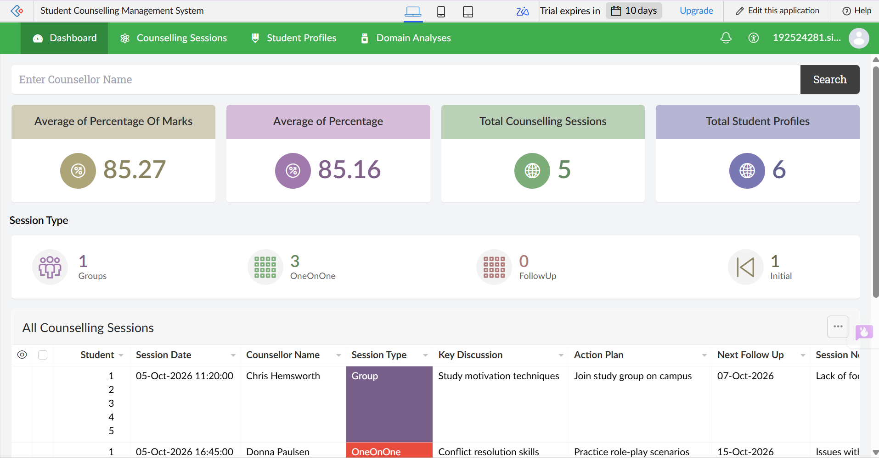
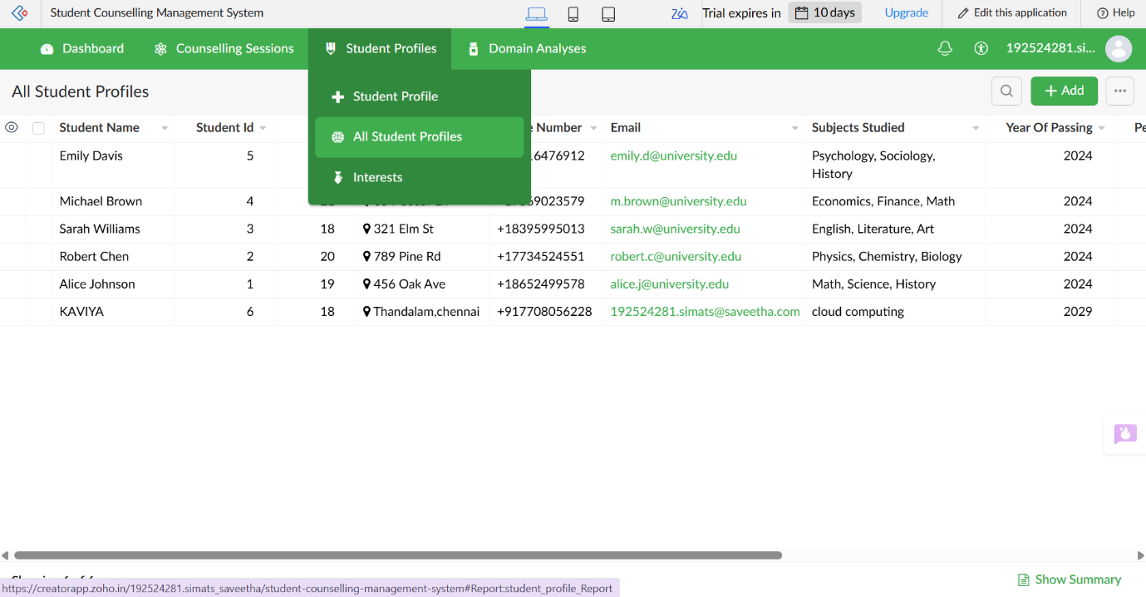

Field | Example
Student Name | Priya
Age | 20
Address | Chennai, Tamil Nadu
Phone | 9876543210
Subjects Studied | Python, DBMS, Cloud Computing
Year of Passing | 2026
Percentage of Marks | 85%
Domain Interest | Artificial Intelligence
Career Goal | AI Engineer
Counselling Remarks | Recommended to pursue AI/ML courses
RESULT
Thus, a cloud-based Student Counselling System was successfully created and deployed using a Cloud Service Provider. The application stores student personal and academic information and helps counsellors provide suitable career guidance, demonstrating the concept of Software as a Service (SaaS).

9. HOSPITAL INFORMATION SYSTEM USING CLOUD SaaS
AIM
To develop a simple cloud-based Hospital Information System for SIMATS Hospital using a Cloud Service Provider to demonstrate the Software as a Service (SaaS) model, including patient, attender, doctor, and disease-related information.
PROCEDURE
1. Select a Cloud Service Provider
Use any cloud platform such as Google Cloud Platform (GCP), AWS, or Microsoft Azure.
2. Create the Web Application
Develop a simple web-based Hospital Information System that can be accessed through the internet.
3. Add the Required Fields
- Patient Name
- Patient ID
- Age
- Gender
- Address
- Phone Number
- Email ID
- Attender Name
- Attender Phone Number
- Doctor Name
- Department
- Disease / Diagnosis
- Date of Admission
- Room / Ward Number
- Treatment Details
- Prescription
- Medical Remarks
4. Enter Patient Details
Enter the patient's personal information such as name, age, address, phone number, and email.
5. Enter Attender Details
Record the name and phone number of the patient's attender.
6. Enter Doctor Details
Add the assigned doctor's name and department.
7. Record Medical Information
Enter the patient's disease/diagnosis, treatment details, prescription, and other relevant medical information.
8. Store Information in the Cloud
Store patient and hospital records securely in a cloud database so that authorized hospital staff can access them through the web application.
9. Deploy the Application
Deploy the application on the selected cloud platform and access it using a web browser.
10. Test the Application
Verify that patient records can be added, viewed, updated, and retrieved correctly.
SAMPLE OUTPUT
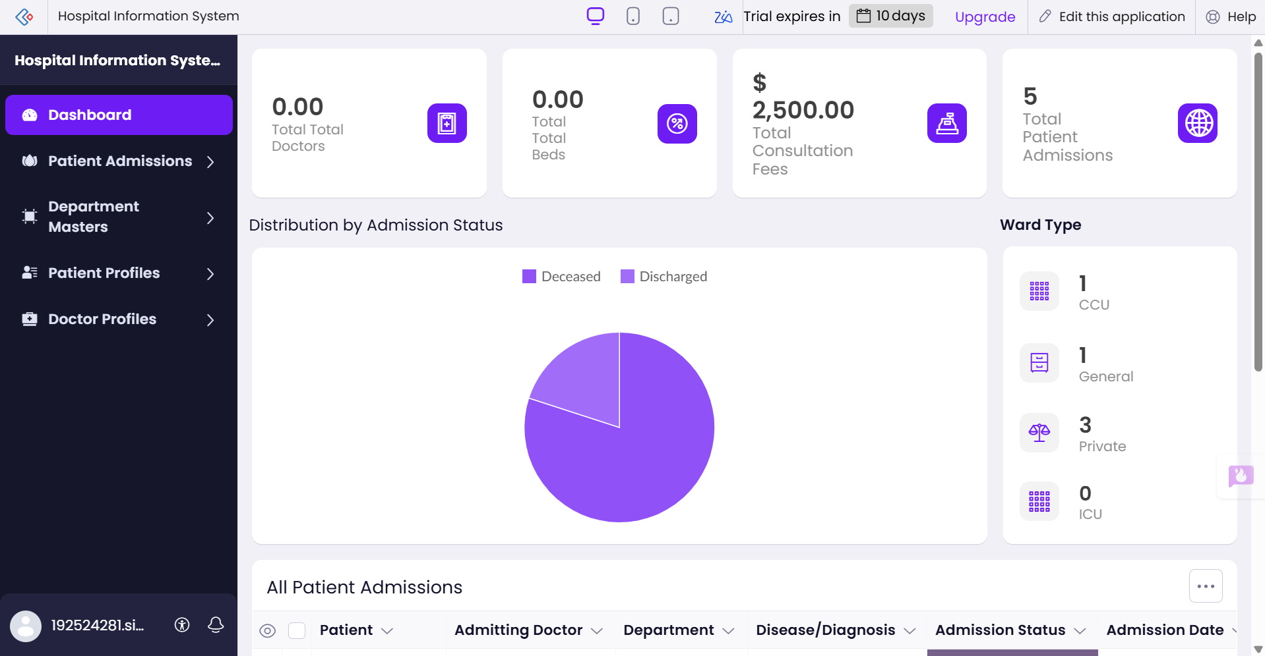

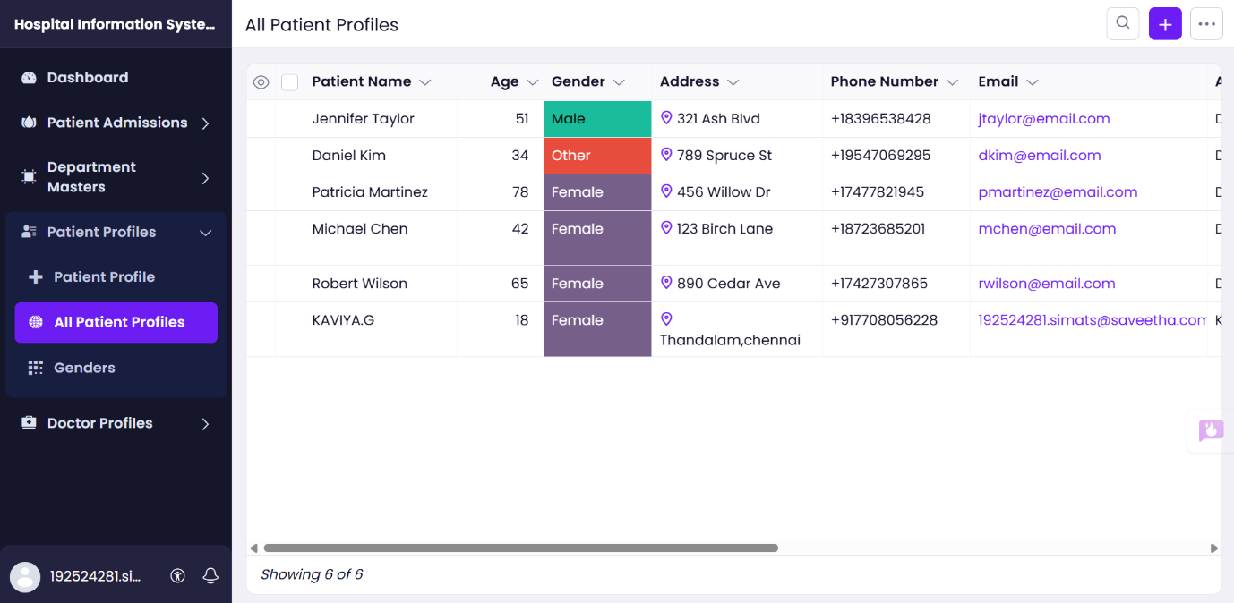

Field | Example
Patient Name | Rahul Kumar
Patient ID | SIMH001
Age | 35
Address | Chennai, Tamil Nadu
Phone | 9876543210
Email | rahul@example.com
Attender Name | Priya Kumar
Attender Phone | 9876501234
Doctor Name | Dr. Arun
Department | General Medicine
Disease / Diagnosis | Fever
Date of Admission | 05-10-2026
Room / Ward | Ward 12
Treatment | Medication and observation
Medical Remarks | Follow-up required
RESULT
Thus, a cloud-based Hospital Information System for SIMATS Hospital was successfully created and deployed using a Cloud Service Provider. The system manages patient, attender, doctor, and medical information through a web application, thereby demonstrating the concept of Software as a Service (SaaS).

Experiment 10– Student Information System
Question:
Create a simple cloud software application to run a C program to display student information using any Cloud Service Provider to demonstrate SaaS with the template of student name, register number, address, phone, age, courses, grades, attendance report, progress report and semester mark sheet.
Aim:
To develop a simple cloud-based Student Information System using SaaS for storing and displaying student academic and personal information.
Procedure:
- Open the selected Cloud Service Provider/cloud application builder.
- Create a new web application named Student Information System.
- Create forms for student details, courses, grades and attendance.
- Add progress report and semester mark sheet sections.
- Add a C program section to display student information.
- Add sample student data and test all forms.
- Save and deploy the application on the cloud.
- Verify the application through the deployed website.
OUTPUT:
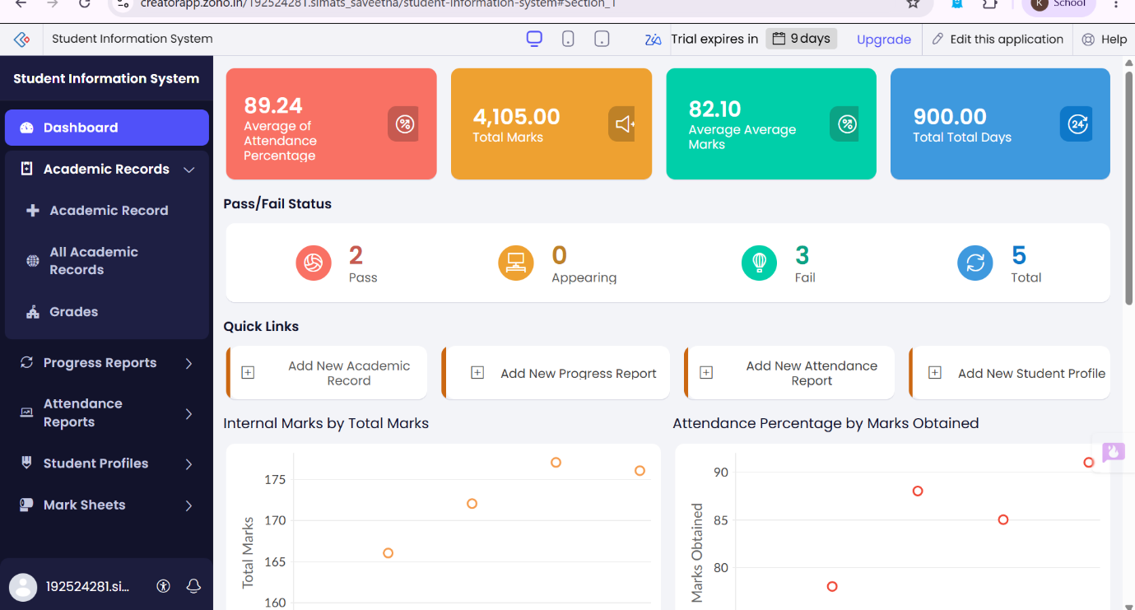
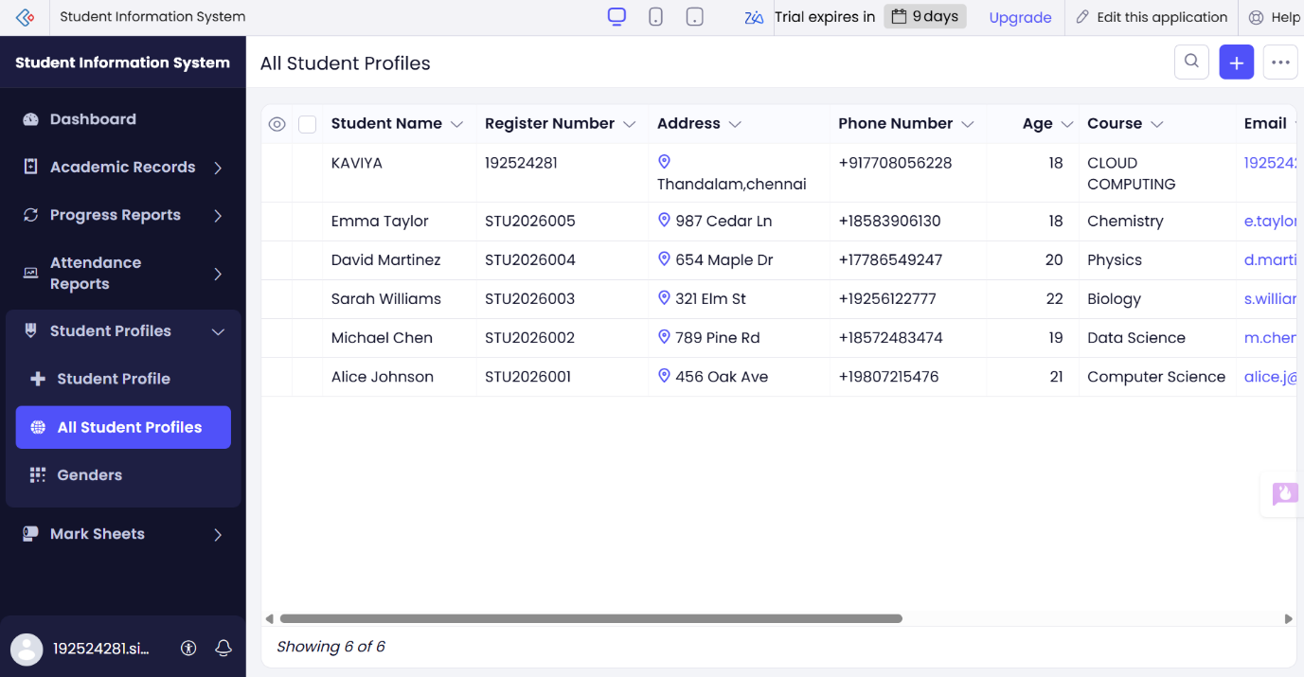
Result:
Thus, a simple cloud-based Student Information System was created successfully using SaaS, with student details, attendance, progress report and semester mark sheet features.

Experiment 11 – Online Super Market
Question:
Create a simple cloud software application for an Online Super Market using any Cloud Service Provider to demonstrate SaaS with the template of customer name, address, phone, email, items, quantity, etc., along with an item classification form.
Aim:
To develop a simple cloud-based Online Super Market application using SaaS for managing customer details, products, categories and orders.
Procedure:
- Open the selected Cloud Service Provider/cloud application builder.
- Create a new web application named Online Super Market.
- Create a customer form with name, address, phone and email.
- Create item classification categories such as groceries, fruits, dairy and snacks.
- Add item name, price and quantity fields.
- Create a cart/order section to calculate the total amount.
- Add sample products and test the application.
- Save and deploy the application on the cloud.
- Verify the customer, item and order details.
OUTPUT:
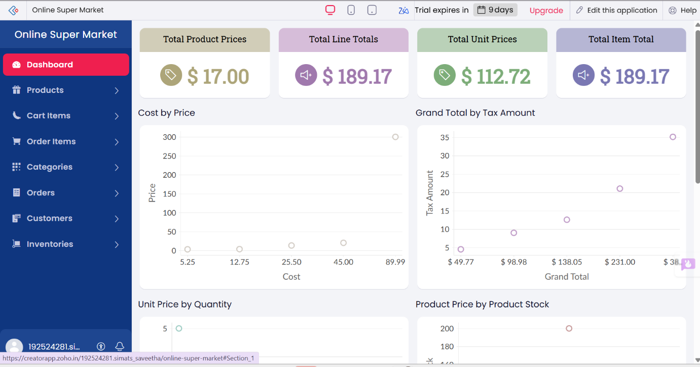
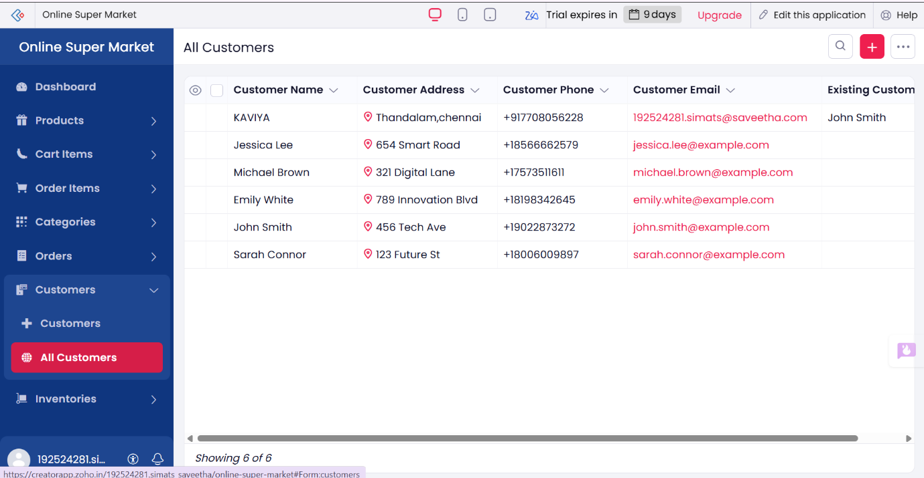
Result:
Thus, a simple cloud-based Online Super Market application was created successfully using SaaS with customer details, item classification, quantity and order management features.

